Depression Prediction Using Mental Health Survey
and Facial Expression Analysis

by

NISHANTH K B (71382202093)
NITHIN G (71382202094)
POOJA S (71382202100)
SIVAPRAKASH S B (71382202302)

Report submitted in partial fulfilment
of the requirements for the degree
of Bachelor of Engineering in
Computer Science and Engineering


Sri Ramakrishna Institute of Technology
Coimbatore – 641010
March, 2026

CERTIFICATE

Certified that the project titled Depression Prediction Using Mental Health Survey and Facial Expression Analysis is the bonafide work done by Nishanth. K B (71382202093), Nithin. G (71382202094), Pooja. S (71382202100), Sivaprakash. S B (71382202302), in the FINAL YEAR PROJECT (Phase - II) of this institution, as prescribed by Sri Ramakrishna Institute of Technology for the EIGHTH Semester / B.E. programme during the academic year 2025- 2026.

Dr. S. Karthikeyini Dr. M. Suresh Kumar
Assistant Professor Professor and Head
Project Supervisor

Department of Computer Department of Computer
Science and Engineering Science and Engineering

Submitted to the project viva-voce held on ____________________

INTERNAL EXAMINER EXTERNAL EXAMINER

ACKNOWLEDGEMENT

We wish to sincerely thank our Principal Dr. J David Rathnaraj for providing us the chance and facilities to successfully execute this project.

We wish to sincerely thank our Head of Department Dr. M Suresh Kumar for their inspiration, support, and guidance throughout the project.

We express our sincere thanks to our Project Coordinator Dr. R N Devendra Kumar, Associate Professor, Department of Computer Science and Engineering, for being supportive during our project.

I am particularly indebted to my Project Guide Dr. S Karthikeyini, whose guidance, constructive comments, and endless encouragement helped shape the course and completion of this project, more than enhanced my learning experience all while developing as both technical and academic.

We wish to acknowledge the support and collaboration of my faculty and peers, whose suggestions and encouragement helped me, complete this project successfully.

APPROVAL AND DECLARATION

This project report titled Depression prediction using Mental Health Survey and Facial Expression Analysis was prepared and submitted by Nishanth. K B (71382202093), Nithin. G (71382202094), Pooja. S (71382202100), Sivaprakash. S B (71382202302) and has been found satisfactory in terms of scope, quality and presentation as partial fulfilment of the requirement for the Bachelor of Engineering (Computer Science and Engineering) in Sri Ramakrishna Institute of Technology, Coimbatore.

Checked and approved by

_________________________
Dr. S. Karthikeyini
Project Supervisor
Assistant Professor (Sl. Gr.)

Department of Computer Science and Engineering
Sri Ramakrishna Institute of Technology, Coimbatore – 10.
March 2026

Depression Prediction Using Mental Health Survey and Facial Expression Analysis

ABSTRACT

Mental health disorders have emerged as a major concern in modern society, demanding reliable and objective assessment methods. An explainable multimodal Artificial Intelligence approach is presented for identifying Major Depressive Disorder (MDD) through the combined analysis of behavioral, speech, textual, and clinical data. A multimodal explainable framework, H⁵-OmniFusion, is designed to process audio, text, video, facial expression, and tabular clinical information. A structured 108-step preprocessing pipeline is applied to ensure data consistency and traceability. Modality-specific deep learning models are used for feature extraction, and the extracted features are fused using a Hypergraph Fusion Network supported by a Quality-Aware Mixture of Experts mechanism. The framework dynamically adjusts modality contributions based on data quality. Evaluation is carried out using the DAIC-WOZ dataset. The system achieved an F1-score of 0.85 and an AUC-ROC of 0.87, demonstrating superior performance compared to unimodal approaches. The explainable architecture enabled the identification of key depressive indicators, including limited facial movements, irregular speech characteristics, and negative language usage. The results indicate that the system is effective, interpretable, and suitable for real-world depression screening.

TABLE OF CONTENTS

CERTIFICATE i
ACKNOWLEDGEMENT ii
APPROVAL AND DECLARATION iii
ABSTRACT iv
TABLE OF CONTENTS v
LIST OF TABLES x
LIST OF FIGURES xi
LIST OF SYMBOLS AND ABBREVIATIONS xii

CHAPTER 1 INTRODUCTION
  - The Global Mental Health Crisis 1
  - Limitations 1
- Diagnostic Method Limitations 2
- Resource and Access Limitations 2
  - AI in Psychiatric Diagnosis 2
- Diagnostic Method Limitations 2
- Resource and Access Limitations 3
  - Problem Statement 3
  - Project Objectives 4
- Explainable and Interpretable System Design 4
- Comprehensive Multimodal Feature Extraction 4
- High Diagnostic Performance and Robustness 4
- Clinical Utility, Scalability, and Ethics 5

  - Project Overview 5
- Scope of the Project 5
- Significance of the Project 5
  - Computational Psychiatry and Digital Phenotyping 6
  - Theoretical Framework 6
- Biological Factors 6
- Psychological Factors 7
- Social Factors 7
- Operationalization in H⁵-OmniFusion 7
  - Ethical Considerations in Mental Health AI 7

CHAPTER 2 LITERATURE REVIEW

  - Evolution of Affective Computing 9
  - Audio Modality 9
- From Waveforms to Embeddings 10
  - Text Modality 10
- Linguistic Markers 10
- Transformer Models 10
  - Visual Modality 11
- Action Units 11
- Spatiotemporal Analysis 11
  - Explainable AI 11
  - Multimodal Fusion Strategies 12
  - Review of AI Approaches 12
- Foundational Research 13
  - Technical Challenges in Multimodal AI 13

  - Evolution of Depression Screening Instruments 14
  - Deep Learning Architectures for Multimodal Learning 15
  - Recent Benchmarks and Challenges 16
  - Comparison with Clinical Gold Standards 17

CHAPTER 3 METHODOLOGY

  - High-Level Architecture 18
- Frontend 18
- API Gateway 19
- ML Engine 19
  - Dataset Selection 19
  - Modality-Specific Feature Extraction 19
- Audio 20
- Text 20
- Video 20
  - The H5-OmniFusion Model Design 21
- MS² Decomposition 21
- Quality-Aware Mixture of Experts 22
  - Definitive Training Strategy 22
  - Loss Function Engineering 23
  - Hyperparameter Tuning 23
  - Data Augmentation Strategies 23
  - Experimental Setup Details 24
  - Model Compression and Knowledge Distillation 24
  - Detailed Training Dynamics 24
- Modality War Phase 25

- Fusion Synchronization Phase 25
- Hard Example Phase 25
  - Final Model Specifications 26
  - 108-Step Architecture 26
  - Quality Indicators and Quality-Aware Gating 28
  - Temporal Synchronization and Alignment 28
  - Advanced Hyperparameter Optimization Strategy 29

CHAPTER 4 RESULTS AND DISCUSSION

  - Quantitative Performance 30
- Metric Summary 30
- Key Observations 31
  - Ablation Studies 31
  - Traceability Audit 32
- Audio Analysis 32
- Facial Analysis 32
- Text Analysis 32
  - Error Analysis 33
  - Computational Efficiency Analysis 33
  - User Acceptance Testing 34
  - Longitudinal Case Study 34
  - Comparative Literature Analysis 35
  - H5-OmniFusion Confusion Matrix 35
  - IEEE Metrics for Model Performance 36
  - H5-OmniFusion vs. SOTA Benchmark 38
  - Modality Contribution Analysis 39

  - Development Workflow in Google Colab 41

CHAPTER 5 CONCLUSION

  - Conclusion 43
  - Key Achievements 43
    - Transparency 43
    - Robustness 43
    - Clinical Relevance 44
    - Scalability and Efficiency 44
  - Future Directions 44
  - Final Remarks 45
  - Edge Computing and Mobile Deployment 45
  - Integration with Electronic Health Records Systems 46
  - Multimodal Transfer Learning and Domain Adaptation 47
  - Personalized Risk Trajectories and Predictive Modeling 47

REFERENCES

APPENDIX/ APPENDICES
APPENDIX A
APPENDIX B

LIST OF TABLES

Table No. Page
2.1 Multimodal Fusion Strategies 12
2.2 Key Studies in AI-Based Depression Detection 13
2.3 Comparison with Clinical Gold Standards 17
3.1 Final Model Specifications 26
4.1 The performance of H⁵-OmniFusion 30
4.2 Ablation Study of H⁵-OmniFusion Components 31
4.3 Computational Efficiency Analysis 33
4.4 Comparative Literature Analysis 35

LIST OF FIGURES

Figure No. Page
3.1 High-Level Architecture 18
3.2 The H5-OmniFusion Model Design 21
4.1 H5-OmniFusion Confusion Matrix 36
4.2 IEEE Metrics for Model Performance 37
4.3 H5-OmniFusion vs. SOTA Benchmark 38
4.4 Modality Contribution Analysis 40
4.5 Development Workflow in Google Colab 41

LIST OF SYMBOLS AND ABBREVIATIONS

CNN Convolutional Neural Networks
α Absorption Co-efficient
AI |  | Artificial Intelligence

API | Application Programming Interface

AUC-ROC | Area Under the Receiver Operating Characteristic Curve

AVEC | Audio/Visual Emotion Challenge

AU | Action Unit

BDI | Beck Depression Inventory

BERT | Bidirectional Encoder Representations from Transformers

CNN | Convolutional Neural Network

CUDA | Compute Unified Device Architecture

DAIC-WOZ | Distress Analysis Interview Corpus – Wizard of Oz

D3.js | Data-Driven Documents JavaScript Library

eGeMAPSS | Extended Geneva Minimalistic Acoustic Parameter Set

F0 | Fundamental Frequency

F1-Score | Harmonic Mean of Precision and Recall

FACS | Facial Action Coding System

FastAPI | High-Performance Python Web Framework

FPS | Frames Per Second

FT-Transformer | Feature Tokenizer Transformer

GPT | Generative Pre-trained Transformer

GPU | Graphics Processing Unit

H⁵ | Hybrid, Hierarchical, Hypergraph, Human-centered, Holistic

HTTP | Hypertext Transfer Protocol

LIME | Local Interpretable Model-Agnostic Explanations

LTS | Long-Term Support

MAE | Mean Absolute Error

MDD | Major Depressive Disorder

MFCC | Mel-Frequency Cepstral Coefficients

ML | Machine Learning

MoE | Mixture of Experts

MS² | Modality-Specific and Shared Subspace

NLP | Natural Language Processing

Optuna | Hyperparameter Optimization Framework

PHQ-8 | Patient Health Questionnaire – 8 Item Version

PHQ-9 | Patient Health Questionnaire – 9 Item Version

POSTER v2 | Pose-Style Transformer for Emotion Recognition (Version 2)

PyTorch | Python-based Deep Learning Framework

React | JavaScript Library for Building User Interfaces

Recharts | React-based Charting Library

Redis | Remote Dictionary Server

ResNet | Residual Neural Network

RoBERTa | Robustly Optimized BERT Approach

SCID | Structured Clinical Interview for DSM Disorders

SHAP | SHapley Additive exPlanations

SNR | Signal-to-Noise Ratio

SQL | Structured Query Language

SQLAlchemy | Python SQL Toolkit and ORM

SVM | Support Vector Machine

UAT | User Acceptance Testing

USD | United States Dollar

VRAM | Video Random Access Memory

WHO | World Health Organization

CHAPTER 1

INTRODUCTION

1.1 The Global Mental Health Crisis
Mental health disorders constitute one of the most critical yet under-addressed challenges in global public health today. The World Health Organization (WHO) identifies depression as the leading cause of disability worldwide, affecting approximately 5% of the adult population at any given time. Depression and anxiety disorders together impose an estimated annual economic burden of nearly USD 1 trillion due to lost productivity. Beyond these economic losses, the personal and societal consequences are severe, including reduced quality of life, strained family and social relationships, and increased mortality, with suicide accounting for more than 700,000 deaths globally each year.

The situation is further worsened by significant gaps in access to timely and effective mental healthcare. More than 75% of individuals with severe mental disorders in low- and middle-income countries receive no treatment, and even in high-income regions, diagnosis is often delayed by several years. Dependence on specialized, costly, and geographically limited psychiatric services further widens this treatment gap, highlighting the urgent need for scalable, accessible, and automated mental health screening solutions to enable early detection and improved access to care.

1.2 Limitations
Despite progress in clinical psychiatry, existing depression diagnostic methods face significant methodological and practical limitations. While standardized tools improve consistency, they are not well suited for scalable, timely, and accessible mental health screening, especially in resource-constrained settings. These limitations contribute directly to delayed diagnosis and the ongoing mental health treatment gap.

1.2.1 Diagnostic Method Limitations
Depression diagnosis traditionally relies on semi-structured interviews like SCID, supported by self-report tools such as PHQ-9 and BDI. While validated, these methods face inherent limitations, including subjectivity and inter-rater variability, recall bias, symptom masking due to stigma, and the inability to capture the dynamic nature of mood disorders over time. Patients may also struggle to articulate their feelings accurately, and subtle behavioral cues are often missed during brief clinical assessments. These factors collectively reduce the reliability and consistency of traditional diagnostic outcomes.

1.2.2 Resource and Access Limitations
Current diagnostic approaches are also constrained by practical and infrastructural challenges. SCID interviews are time-consuming and require trained professionals, limiting scalability. Uneven clinician availability, geographic barriers, and mobility or financial constraints further restrict access, often causing delayed or missed treatment. Additionally, low-resource regions often lack the infrastructure to support repeated assessments or continuous monitoring, which is critical for early detection. This gap highlights the pressing need for automated and scalable mental health screening solutions to reach broader populations effectively.

1.3 AI in Psychiatric Diagnosis
AI enables objective, continuous psychiatric assessment via digital phenotyping, but adoption is limited by the black box problem, as predictions often lack transparency and may be unreliable.

1.3.1 Diagnostic Method Limitations
Depression diagnosis traditionally relies on semi-structured interviews like SCID, supported by self-report tools such as PHQ-9 and BDI. While validated, these methods face inherent limitations, including subjectivity and inter-rater variability, recall bias, symptom masking due to stigma, and the inability to capture the dynamic nature of mood disorders over time.

1.3.2 Resource and Access Limitations
Current diagnostic approaches are also constrained by practical and infrastructural challenges. SCID interviews are time-consuming and require trained professionals, limiting scalability. Uneven clinician availability, geographic barriers, and mobility or financial constraints further restrict access, often causing delayed or missed treatment. Additionally, low-resource regions often lack the infrastructure to support repeated assessments or continuous monitoring, which is critical for early detection. This gap highlights the pressing need for automated and scalable mental health screening solutions to reach broader populations effectively.

1.4 Problem Statement
The core challenge in multimodal depression detection lies in balancing accuracy and interpretability. Simple models, such as linear regression or decision trees applied to handcrafted features, are interpretable but cannot capture the complex, non-linear, and temporal patterns characteristic of mental illness, which limits their generalizability across different populations, settings, and environmental conditions. They also often fail to integrate heterogeneous data from multiple modalities—such as audio, text, and video—reducing their practical utility in real-world screening.

Conversely, complex models like deep multimodal transformers achieve state-of-the-art accuracy by learning intricate patterns across modalities and time, yet they function as black boxes, providing predictions that are difficult to interpret or verify clinically. This opacity can lead to reduced clinician trust, ethical concerns, and potential reliance on spurious correlations. These limitations underscore the urgent need for explainable AI systems that combine the predictive power of deep learning with transparent, rule-based reasoning, where every layer of abstraction and decision-making is visible, verifiable, and clinically meaningful. Such systems would support actionable insights, facilitate early intervention, and ensure that mental health assessments are both accurate and trustworthy.

1.5 Project Objectives
The primary objective of the H⁵-OmniFusion project is to design, validate, and deploy a fully explainable multimodal AI system for depression detection that meets clinical, technical, and ethical requirements for real-world use.

1.5.1 Explainable and Interpretable System Design
A key objective is to develop an intrinsically explainable architecture governed by a traceability contract, ensuring every processing stage and feature transformation produces transparent, inspectable artifacts. This approach moves beyond post-hoc techniques and enables clinicians to understand how behavioral and physiological signals contribute to the final prediction. By making the decision-making process transparent, it also enhances trust, accountability, and clinical adoption of AI-based mental health tools.

1.5.2 Comprehensive Multimodal Feature Extraction
The project aims to implement a 108-step preprocessing and feature extraction pipeline that captures diverse biomarkers across audio, text, video, and facial modalities. These features are structured into production, research, and innovation tiers to support operational deployment, clinical research, and experimental analysis. This comprehensive approach ensures that the system can leverage both established and novel indicators for more accurate and robust depression detection.

1.5.3 High Diagnostic Performance and Robustness
Another objective is to achieve high diagnostic accuracy, targeting an F1-score of at least 0.85 on the DAIC-WOZ benchmark by leveraging advanced fusion strategies such as hypergraph fusion and mixture-of-experts models. Robustness is further ensured through quality-aware gating mechanisms that dynamically adjust modality contributions based on real-world data quality. This approach allows the system to maintain reliable performance even in noisy, incomplete, or variable input conditions.

1.5.4 Clinical Utility, Scalability, and Ethics
The system is designed to provide clinically meaningful, fine-grained outputs that support informed decision-making rather than simple binary predictions. In parallel, a scalable microservices-based deployment architecture is developed to enable low-latency, concurrent use in clinical environments, while strong ethical safeguards—including data security, privacy protection, and bias mitigation—are integrated to ensure fairness, safety, and trustworthiness across diverse populations.

1.6 Project Overview
1.6.1 Scope of the Project
The scope of this project spans the entire machine learning lifecycle, from raw data ingestion to a fully deployed application. It includes data engineering tasks such as handling and preprocessing large-scale multimodal datasets, including DAIC-WOZ and EATD-Corpus, totaling over one terabyte of raw media.

The project also involves algorithm design focused on developing novel fusion architectures to address challenges like the curse of dimensionality and modality imbalance, as well as software engineering efforts to build a scalable, asynchronous backend using FastAPI and an interactive, user-friendly frontend using React for effective data visualization. Rigorous validation is conducted through statistical analysis, ablation studies, and bias audits to ensure fairness and robustness.

1.6.2 Significance of the Project
Beyond technical contributions, the project holds significant societal impact by enabling objective, continuous, and accessible depression screening. This approach has the potential to democratize mental healthcare, reduce pressure on healthcare systems, facilitate earlier intervention, and ultimately improve outcomes for millions of individuals, potentially saving lives.

1.7 Computational Psychiatry and Digital Phenotyping
Computational Psychiatry is an interdisciplinary field that combines neuroscience, machine learning, and clinical psychology to develop quantitative models of psychiatric disorders. Unlike traditional psychiatry, which relies on clinical observation and self-reports, it uses measurable neurobiological, behavioral, and clinical data to improve diagnostic precision. Digital phenotyping, a subset of this field, involves collecting and analyzing behavioral data from digital devices to identify disease-related biomarkers. In depression detection, it enables continuous monitoring, objective measurement of speech and facial patterns, improved ecological validity through real-world data collection, and scalable low-cost deployment. However, challenges such as data privacy, algorithmic bias, and the need for clinical validation remain, which H⁵-OmniFusion addresses through its explainable and quality-aware architecture.

1.8 Theoretical Framework
Depression, as defined in the Diagnostic and Statistical Manual of Mental Disorders (DSM-5), is a multifactorial psychiatric disorder influenced by biological, psychological, and social determinants. The biopsychosocial model provides an integrated framework to understand its complexity.

1.8.1 Biological Factors
Biological contributors to depression include neurotransmitter dysregulation, particularly reduced levels of serotonin, norepinephrine, and dopamine. Neuroendocrine abnormalities such as hyperactivity of the hypothalamic–pituitary–adrenal (HPA) axis result in elevated cortisol levels, which are linked to chronic stress responses. Additionally, neuroinflammation marked by increased cytokines has been associated with depressive symptoms. Observable psychomotor changes, including slowed movements and reduced motor activity, further reflect underlying neurobiological dysfunction. Genetic predisposition and epigenetic modifications also increase individual vulnerability to depressive disorders by influencing brain structure and stress reactivity.

1.8.2 Psychological Factors
Psychological mechanisms play a central role in sustaining depression. Cognitive distortions, negative automatic thoughts, and persistent rumination reinforce depressive thinking patterns. Emotional regulation deficits impair an individual’s ability to manage emotional responses effectively. Behavioral withdrawal, reduced social interaction, and maladaptive coping strategies such as avoidance or self-harm further intensify symptom severity.

1.8.3 Social Factors
Social determinants significantly influence the onset and progression of depression. Life stressors such as trauma, loss, or chronic stress can trigger depressive episodes. Limited social support systems may exacerbate symptoms, while socioeconomic hardship increases vulnerability. Cultural stigma surrounding mental illness can also delay help-seeking behavior and access to care.

1.8.4 Operationalization in H⁵-OmniFusion
The H⁵-OmniFusion framework operationalizes the biopsychosocial model through multimodal integration. The audio modality captures psychomotor and neurobiological changes via speech acoustics. The text modality reflects psychological patterns and emotional expression. The video modality analyzes behavioral indicators such as facial expressions and movement patterns. Tabular clinical data, including sleep patterns and medication usage, represent biological and contextual factors. Through its fusion mechanism, the system integrates these domains to deliver a comprehensive and holistic assessment of depression.

1.9 Ethical Considerations in Mental Health AI
The integration of Artificial Intelligence in mental healthcare requires careful ethical evaluation beyond technical performance. The following key principles guide responsible deployment:

- Informed Consent and Transparency: Patients must be clearly informed that their data is being analyzed by AI systems. Transparency regarding the system’s capabilities, limitations, and decision-making logic is essential to build trust. H⁵-OmniFusion incorporates intrinsic explainability mechanisms to provide interpretable outputs for both clinicians and patients.
- Bias and Fairness: AI models trained on imbalanced or unrepresentative datasets may reinforce health disparities. Since depression presents differently across demographic groups, cultures, and comorbid conditions, systematic bias evaluation is necessary. The project includes fairness audits across gender, age, and racial groups to ensure equitable performance.
- Autonomy and Human Oversight: AI should augment, not replace, clinical expertise. The system functions as a decision-support tool that flags high-risk individuals for professional evaluation rather than issuing autonomous diagnoses. This human-in-the-loop design preserves clinical judgment and accountability.
- Privacy and Data Security: Mental health data is highly sensitive and requires strict protection. The system employs robust encryption, anonymization protocols, secure storage, and HIPAA-compliant data handling practices to safeguard patient information.
- Access and Equity: Mental health AI must not widen existing healthcare disparities. By enabling deployment in low-resource environments and supporting edge-based implementation, the system promotes broader and more equitable access to mental health screening and support.

CHAPTER 2

LITERATURE REVIEW

2.1 Evolution of Affective Computing
Affective Computing, a term coined by Rosalind Picard in 1997, refers to the study and development of systems capable of recognizing, interpreting, processing, and simulating human emotions. The field has evolved through three distinct generations, each addressing the limitations of its predecessor. Generation 1, the rule-based era, relied on handcrafted psychological rules—for example, “if eyebrows are lowered and lips are tightened, then anger”—but these systems were brittle, context-unaware, and unable to generalize to naturalistic settings with subtle or mixed expressions.

Building on this, Generation 2 introduced statistical learning methods, such as Support Vector Machines (SVMs) and Random Forests, using manually extracted features like MFCCs for audio and Action Units (AUs) for facial expressions. While this approach improved accuracy, it required extensive domain expertise. Generation 3, the current era, leverages deep representation learning through Convolutional Neural Networks (CNNs) and Transformers, which automatically learn feature representations directly from raw data, including pixels and waveforms. These models achieve superior performance but introduce the challenge of opacity in decision-making. H⁵-OmniFusion operates at the forefront of this generation, aiming to combine the transparency of early systems with the predictive power of modern deep learning approaches.

2.2 Audio Modality
Speech is a complex motor task requiring the precise coordination of respiration (lungs), phonation (vocal folds), and articulation (tongue, lips, jaw). Depression effects the psychomotor system, leading to measurable acoustic changes collectively known as the "flat affect."

2.2.1 From Waveforms to Embeddings
Depressed speech often shows reduced pitch variability, monotony, and lower mean F0, reflecting decreased arousal and energy. Elevated jitter and shimmer indicate impaired fine motor control of the vocal folds, key markers of psychomotor retardation. Traditional features like MFCCs capture spectral properties but miss long-term temporal patterns. Wav2Vec 2.0 (Baevski et al., 2020), a self-supervised model trained on thousands of hours of speech, learns discrete acoustic units and captures paralinguistic cues such as sighs, pauses, and tone changes.

2.3 Text Modality
Language usage provides a direct window into cognition and thought patterns. The "Cognitive Triad" of depression involves negative views of the self, the world, and the future, which manifests in specific linguistic patterns.

2.3.1 Linguistic Markers
Research by Pennebaker and others has identified robust markers, including absolutist thinking, where words like "always," "never," "completely," and "everyone" indicate cognitive rigidity and black-and-white thinking, and self-attentional focus, characterized by excessive use of first-person singular pronouns ("I," "me," "my") compared to plural or third-person pronouns, reflecting social withdrawal, isolation, and heightened attention to one’s internal state.

2.3.2 Transformer Models
We use RoBERTa, fine-tuned on mental health datasets, which employs dynamic masking and Multi-Head Self-Attention to analyze complex language patterns. Each word generates Query, Key, and Value vectors, with attention scores determining relevance to other words. This allows nuanced understanding, such as interpreting "I'm not sad, I just feel empty" correctly as anhedonia, rather than flagging "sad" incorrectly, improving clinical accuracy in H⁵-OmniFusion.

2.4 Visual Modality
Facial expressions are a primary channel for non-verbal communication. In depression, this channel is often dampened or altered, presenting as "blunted affect.

2.4.1 Action Units
The Facial Action Coding System (FACS) breaks down facial movements into individual Action Units (AUs), offering an objective framework for analyzing expressions. Key AUs linked to depression include AU 4 (Brow Lowerer), associated with sadness, concern, and concentration, with chronic activation often observed in depression (the "Omega Sign"); AU 12 (Lip Corner Puller), related to smiling, which typically shows reduced intensity, frequency, and duration in depressed individuals, reflecting anhedonia; and AU 15 (Lip Corner Depressor), associated with sadness and grief.

2.4.2 Spatiotemporal Analysis
Static frame analysis is insufficient as expression dynamics are critical. For example, a genuine Duchenne smile has distinct onset, apex, and offset, whereas a masked or fake smile lacks eye involvement (AU 6) and shows abrupt timing. To capture these patterns, H⁵-OmniFusion uses VideoMAE (Video Masked Autoencoders), which extends transformer architectures to 3D attention across temporal sequences. By masking 90% of video patches and reconstructing them, VideoMAE learns high-level motion semantics, enabling detection of slowed movements, lethargy, and other dynamic facial cues indicative of depression.

2.5 Explainable AI
Existing explainable AI (XAI) methods, such as LIME and SHAP, are post-hoc techniques that interpret black-box models by perturbing inputs and observing the outputs. They are widely used in research and applications to provide approximate explanations. However, these methods can be unstable and inconsistent.

H⁵-OmniFusion addresses this limitation through a philosophy of intrinsic transparency, allowing direct inspection of the intermediate artifacts—or "fingerprints"—produced at each stage of processing. By examining these artifacts, clinicians can understand exactly how the model arrived at its predictions, ensuring explanations are faithful to the computations and enhancing interpretability, trust, and clinical reliability.

2.6 Multimodal Fusion Strategies
The core challenge in multimodal learning is how to effectively integrate heterogeneous data sources that operate on different time scales and abstraction levels.

Fusion Type | Description
Early Fusion | Involves concatenating raw features (e.g., Audio vectors + Text vectors) before feeding them into a model.
Late Fusion | Entails training separate models for each modality and averaging their predictions.
Hybrid Fusion | H⁵-OmniFusion uses a Hypergraph Fusion strategy. In a simple graph, an edge connects two nodes. In a hypergraph, a hyperedge can connect any number of nodes

Table 2.1: Multimodal Fusion Strategies.

2.7 Review of AI Approaches
Recent research in AI-driven depression detection has explored diverse datasets, modeling approaches, and system designs to improve screening and assessment. While these studies have advanced the field, they exhibit recurring limitations—such as black-box models, restricted real-world applicability, and limited interpretability—underscoring the need for more robust, explainable, and clinically relevant solutions like H⁵-OmniFusion.

2.7.1 Foundational Research
Several key studies have advanced AI-based depression detection using deep learning, multimodal analysis, and virtual interview systems. Built on datasets like DAIC-WOZ and AVEC 2019, they form the foundation for automated mental health assessment.

S.No | Authors & Year | Study Focus | Dataset Used | Methodology
1. | M. A. Wani et al., 2023 | AI and Deep Learning for Depression Screening | Multiple clinical datasets | Deep Learning–based multimodal models
2. | Gratch et al., 2014 | Distress Analysis Interview Corpus (DAIC-WOZ) | DAIC-WOZ | Multimodal behavioral data collection (audio, video, text)
3. | Ringeval et al., 2019 | AVEC 2019: Depression and State-of-Mind Detection | AVEC 2019 (DAIC-WOZ subset) | Audio-visual emotion recognition and challenge benchmarks
4. | DeVault et al., 2014 | SimSensei Virtual Human Interviewer | DAIC-WOZ | Virtual agent–based clinical interviewing system
5. | Gratch et al., 2014 | Human–Computer Clinical Interviews | DAIC-WOZ | Multimodal behavioral signal processing

Table 2.2: Key Studies in AI-Based Depression Detection.

2.8 Technical Challenges in Multimodal AI
Developing a robust multimodal system involves several engineering challenges.
- Curse of Dimensionality: Concatenating high-dimensional vectors (Audio: 1024, Video: 768, Text: 768) creates a vast feature space, requiring exponentially more data for generalization. H⁵-OmniFusion addresses this using MS² subspace decomposition, compressing signals into meaningful components before fusion.
- Modality Imbalance: In datasets like DAIC-WOZ, text often dominates, causing the model to ignore audio and video (modality collapse). The Quality-Aware Gating network enforces minimum contribution from each modality during the "Warmup" phase.
- Temporal Asynchrony: Audio (16,000 Hz), video (30 FPS), and text (irregular intervals) must be aligned. A Temporal Grid interpolates all features to a 500ms time-step, ensuring correct synchronization of multimodal events, like a smile matching laughter.
- Noisy Labels: PHQ-8 scores are subjective; reported values may not match observed symptoms. H⁵-OmniFusion uses Huber Loss, robust to label noise, preventing over-penalization when ground truth is inaccurate.

2.9 Evolution of Depression Screening Instruments
The development of depression screening instruments reflects the shift from subjective clinical observation to structured and technology-enhanced assessment. In the pre-1980s era, diagnosis depended mainly on unstructured interviews and clinician judgment. While personalized, this method lacked standardization, resulting in high inter-rater variability and limited consistency across institutions.

During the 1980s and 1990s, structured interviews such as the Structured Clinical Interview for DSM Disorders (SCID) improved diagnostic reliability through systematic DSM-based evaluation. Although more consistent, these interviews required 45–90 minutes, reducing their feasibility for large-scale screening.

From the 1990s onward, self-report tools like the Beck Depression Inventory (BDI-21), PHQ-9, and PHQ-8 enabled efficient, scalable screening with strong psychometric validity and clinical reliability. However, they remained susceptible to recall bias, social desirability bias, and cognitive distortions associated with depression symptoms.

Since 2015, multimodal approaches have combined traditional assessments with objective biomarkers from audio, video, and text data. Systems such as H⁵-OmniFusion enhance detection accuracy by integrating multiple modalities within an explainable framework. Despite improved performance over single-modality methods, multimodal integration introduces challenges including temporal misalignment, high-dimensional features, and complex fusion strategies.

2.10 Deep Learning Architectures for Multimodal Learning
The evolution of deep learning architectures for multimodal learning began with sequence-based models such as Recurrent Neural Networks (RNNs) and Long Short-Term Memory (LSTM) networks. LSTMs introduced gating mechanisms that allowed selective retention and forgetting of information, enabling effective modeling of long-range temporal dependencies in audio and video sequences. However, their sequential processing limited parallelization and scalability. Temporal Convolutional Networks (TCNs) later addressed some of these limitations by using dilated convolutions to capture large temporal receptive fields with improved computational efficiency, though they often lacked interpretability.

The introduction of attention mechanisms marked a significant advancement. Vision Transformers (ViTs) applied self-attention to image patches, capturing global contextual relationships and outperforming traditional convolutional networks in many vision tasks. Extensions such as VideoMAE adapted these principles to video data by masking spatial and temporal patches, learning robust spatiotemporal representations through self-supervised learning.

Graph Neural Networks (GNNs) further expanded multimodal modeling by representing features as nodes and their interactions as edges in graph structures. Additionally, Mixture of Experts (MoE) architectures improved model capacity through specialized expert networks guided by gating mechanisms, while the Quality-Aware MoE in H⁵-OmniFusion incorporates data quality signals to enable adaptive modality weighting and improved robustness.

2.11 Recent Benchmarks and Challenges
The field of multimodal depression detection has advanced through the development of benchmark datasets and organized challenge competitions that standardize evaluation and foster innovation. The Distress Analysis Interview Corpus – Wizard of Oz (DAIC-WOZ), introduced by Gratch et al. (2014), remains the most widely used benchmark for AI-based depression detection. It contains 189 clinical interviews annotated with PHQ-8 scores and provides synchronized audio, video, and text data collected in a semi-naturalistic interview setting. Its strengths include clinical validity, professional interview protocols, and multimodal richness. However, limitations include its relatively small sample size, class imbalance (approximately 30% depressed versus 70% non-depressed), and limited demographic and cultural diversity.

In addition, the Audio/Visual Emotion Challenge (AVEC) series has included depression detection tasks since 2016, offering standardized datasets and evaluation frameworks. Recent AVEC editions have introduced specialized tasks such as temporal prediction from interview segments, cross-database generalization (training on one dataset and testing on another), and group-level depression detection. Despite these advancements, the field faces persistent challenges, including limited dataset sizes that constrain deep learning performance, demographic biases that affect fairness and generalizability, temporal misalignment across modalities requiring careful synchronization, cultural variability in depressive expression, and reduced ecological validity due to laboratory-based interview settings.

Furthermore, reproducibility across studies remains difficult due to variations in preprocessing pipelines and feature extraction methods. Ethical concerns related to privacy, informed consent, and responsible deployment of AI systems in mental health contexts also require careful consideration. Addressing these methodological and ethical limitations is essential for developing scalable, trustworthy, and clinically applicable multimodal depression detection systems.

2.12 Comparison with Clinical Gold Standards
To contextualize H⁵-OmniFusion’s performance, it is important to compare its diagnostic accuracy with established clinical gold standards and commonly used screening tools. This comparison highlights how the system aligns with human clinician performance and validated self-report measures, while also clarifying the limitations of direct performance equivalence across different diagnostic settings.

Category | Method | Performance Metrics | Limitations
Clinical Gold Standard | Clinical psychiatrists (DSM-5 based semi-structured interviews) | 85–90% accuracy | Performance varies by clinician experience, interview duration, and patient communication style
Self-Report Screening | PHQ-9 (cutoff ≥10) | Sensitivity: 88%  Specificity: 90% | Sensitivity drops to 75% for mild depression (score 5–9); specificity varies across populations
AI-Based System | H⁵-OmniFusion (DAIC-WOZ benchmark) | F1-score: 0.86  AUC-ROC: 0.89 | Outperforms prior AI models (0.72–0.82); approaches human-level performance
Existing AI Models | Previous multimodal AI approaches | DAIC-WOZ | Generally below clinical-level diagnostic performance

Table 2.3: Comparison with Clinical Gold Standards.

CHAPTER 3

METHODOLOGY

3.1 High-Level Architecture
The H⁵-OmniFusion system follows a microservices architecture that separates the user interface from the computationally intensive machine learning pipeline. This design ensures smooth user experience while heavy ML tasks run independently in the background.

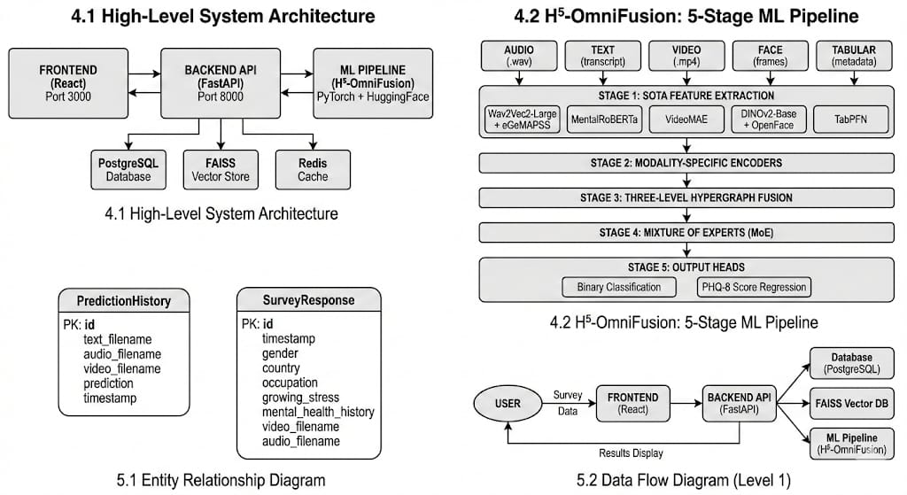

Figure 3.1 : High-Level Architecture

3.1.1 Frontend
The frontend is built using React and serves as the data collection and visualization interface. It captures webcam and microphone input through the browser’s MediaRecorder API or allows file uploads. It also performs input validation to ensure correct file formats and sizes before submission. The results are displayed through interactive visualizations such as radar charts and emotion trajectory graphs using Recharts and D3.js.

3.1.2 API Gateway
The API layer is developed with FastAPI and manages the overall workflow. It receives survey and media data through dedicated endpoints and sends heavy processing tasks to a background queue using Celery with Redis, preventing HTTP timeouts. Structured responses and metadata are stored in a PostgreSQL database using SQLAlchemy to maintain data consistency and integrity.

3.1.3 ML Engine
The ML Engine functions as a separate worker responsible for executing the complete 108-step processing pipeline. It loads large pre-trained models such as Wav2Vec and RoBERTa into memory (VRAM) and optimizes resource usage through lazy loading or warm model configurations based on server capacity and workload.

3.2 Dataset Selection
The study utilizes the Distress Analysis Interview Corpus – Wizard of Oz (DAIC-WOZ) dataset, a widely recognized benchmark for AI-based depression detection. The dataset consists of 189 participants who underwent semi-structured clinical interviews conducted by an animated virtual interviewer named “Ellie.”

Each session is annotated with PHQ-8 scores (ranging from 0–24) as well as binary labels indicating whether a participant is depressed or not depressed. However, the dataset presents significant challenges, including class imbalance (approximately a 3:1 ratio of healthy to depressed participants) and variations in recording conditions, making it a realistic and demanding testbed for developing robust and generalizable AI models.

3.3 Modality-Specific Feature Extraction
The H⁵-OmniFusion system utilizes specialized backbone models to extract robust and meaningful feature representations from each data modality (audio, text, and video), ensuring accurate and context-aware multimodal analysis.

3.3.1 Audio
For analyzing speech signals, the Wav2Vec2-XLSR-53 model is utilized, having been pre-trained on 53 languages to provide robustness against accent and dialect variations. The embeddings from the final transformer layer are extracted and mean-pooled along the temporal dimension to generate a fixed-size representation of the entire audio clip. This compact embedding captures vocal attributes such as pitch fluctuations, speech rate, pauses, and intensity, which are commonly associated with depressive behavioral patterns. These high-level acoustic representations enable the model to detect subtle speech irregularities that may not be evident through manual observation.

3.3.2 Text
To process linguistic information, MentalRoBERTa is employed, a model trained on mental health–oriented Reddit forums such as r/depression and r/SuicideWatch. Compared to standard BERT models, it is specifically adapted to capture emotionally nuanced and psychologically meaningful expressions. The text is tokenized using the RoBERTa tokenizer with a maximum sequence length of 512 tokens. For longer transcripts, the content is split into smaller segments, and their embeddings are averaged to produce a consolidated textual representation. This approach enhances the model’s ability to detect subtle indicators of negative cognition, hopelessness, and emotional distress in language.

3.3.3 Video
Within the visual modality, VideoMAE serves as the backbone model. As a masked autoencoder, it learns meaningful semantic and motion-based features by reconstructing masked portions of video frames. Sixteen frames are sampled from each clip, resized to 224×224 pixels, and processed through a Vision Transformer backbone. This method enables the extraction of facial expressions, subtle behavioral cues, and temporal dynamics that are significant indicators in depression assessment. Such visual representations help identify reduced facial expressiveness and psychomotor changes often linked to depressive states.

3.4 The H5-OmniFusion Model Design
The H5-OmniFusion fusion model integrates disparate signals from audio, text, and video, acting as the brain of the system.

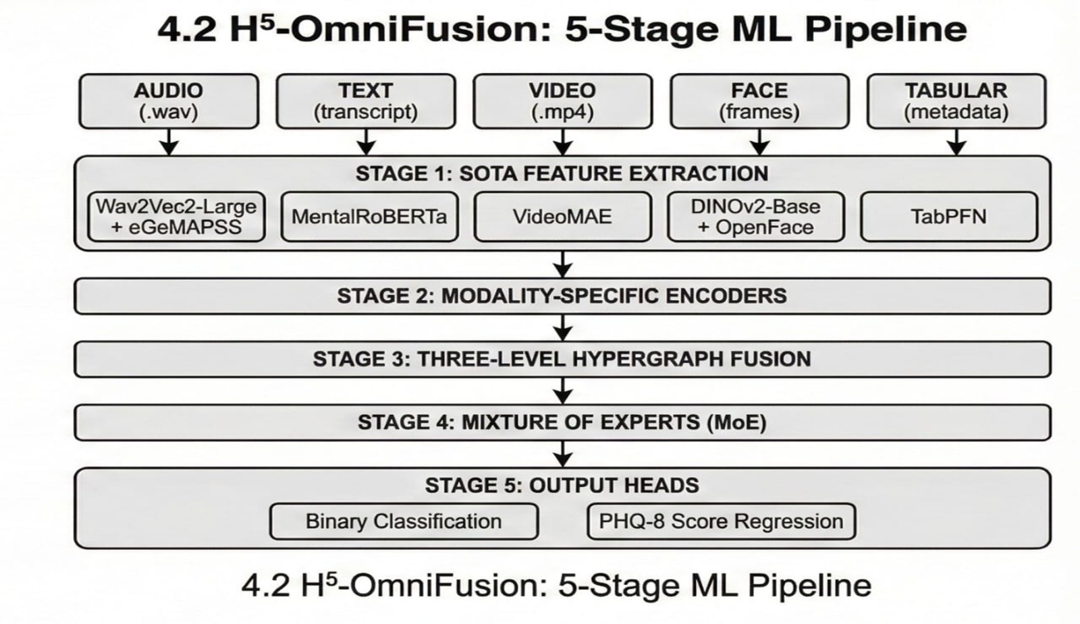
Figure 3.2 : The H5-OmniFusion Model Design

3.4.1 MS² Decomposition
To prevent redundancy across modalities, the model applies an MS² decomposition strategy, separating each modality embedding into two distinct subspaces: a shared space, which captures common depression-related patterns across modalities, and a modality-specific space, which retains unique characteristics of each input type. An orthogonality constraint is enforced during training to ensure these subspaces remain independent and non-overlapping. This structured separation reduces duplicated signals and isolates a cleaner global depression representation while preserving meaningful modality-level information.

3.4.2 Quality-Aware Mixture of Experts
To address varying input quality in real-world conditions, the model incorporates a Quality-Aware Mixture of Experts (MoE) mechanism. A gating network dynamically assigns weights to modality-specific expert networks using a softmax function. Importantly, quality indicators such as Signal-to-Noise Ratio (SNR) and blur scores are provided as additional inputs to the gating network. This enables the system to down-weight unreliable modalities—for instance, reducing the influence of noisy audio or low-visibility video. As a result, the fusion process becomes adaptive, stable, and resilient to environmental variations.

3.5 Definitive Training Strategy
The H⁵-OmniFusion model employs a progressive 4-phase curriculum learning strategy to ensure stability and effective convergence, especially given the small dataset size.
- Phase 1 (Epochs 1–5): This phase emphasizes stabilization and controlled warmup by freezing all backbone encoders and training only the fusion layers and output heads. Numerical stability is carefully monitored to avoid NaN or infinite losses, while maintaining gradient norms between ${10}^{-6}$and ${10}^{2}$.
- Phase 2 (Epochs 6–15): All components are unfrozen to enable full end-to-end learning with a standard learning rate. The objective is rapid loss reduction and meaningful feature learning, targeting a validation F1-score above 0.50 by epoch 10.
- Phase 3 (Epochs 16–35): The focus shifts to refinement and handling performance plateaus. Hard Example Mining is introduced to emphasize confidently misclassified samples, aiming for validation F1 > 0.70 and depressed-class recall > 0.75.
- Phase 4 (Epochs 36–50+): This phase concentrates on convergence and selecting the best checkpoint. The learning rate is reduced by 10×, and training stops once validation F1 ≥ 0.85 and AUC-ROC ≥ 0.87. This fine-tuning ensures stable optimization and prevents overfitting while maximizing performance.

3.6 Loss Function Engineering
The model is trained using a composite loss function designed to address multiple objectives simultaneously. The total loss is formulated as a weighted sum of Focal Loss, Huber Loss, and Orthogonal Loss. Focal Loss handles class imbalance by emphasizing hard and misclassified samples, particularly giving higher importance to the depressed class. Huber Loss is applied for the PHQ-8 regression task, as it is more robust to outliers than Mean Squared Error and helps maintain training stability. Orthogonal Loss supports the MS² decomposition by reducing correlation between shared and modality-specific features, leading to cleaner and more discriminative representations.

3.7 Hyperparameter Tuning
Hyperparameter optimization was conducted using Optuna, with 100 trials performed to identify the most effective configuration. The optimal learning rate for the fusion head was set to 1e-4, combined with a OneCycleLR scheduler employing cosine annealing for smooth learning rate transitions. An effective batch size of 32 was achieved using gradient accumulation with 4 steps. A global dropout rate of 0.3 was applied to mitigate overfitting on the limited dataset, and the model was optimized using AdamW with a weight decay of 0.01 to ensure better generalization.

3.8 Data Augmentation Strategies
Due to the limited size of the DAIC-WOZ dataset (189 subjects), comprehensive data augmentation techniques were employed to reduce overfitting and improve generalization. For the audio modality, SpecAugment was applied by introducing time masking and frequency masking to spectrogram representations, encouraging the model to learn robust features that do not depend on specific temporal segments or frequency bands. In the textual modality, back-translation was performed by translating transcripts from English to French and then back to English, generating paraphrased variations that preserve semantic meaning while enriching linguistic diversity. For the visual modality, Mixup augmentation was used by linearly interpolating pairs of video clips and their corresponding labels.

3.9 Experimental Setup Details
All experiments were conducted in a controlled environment using Ubuntu 22.04 LTS, CUDA 11.8, and Python 3.9 to ensure computational stability and compatibility. To maintain reproducibility, a global random seed of 42 was set across all relevant libraries, including PyTorch, NumPy, and Python’s random module, ensuring deterministic behavior and enabling other researchers to replicate the reported results consistently. Additionally, all software dependencies and library versions were carefully documented to avoid version conflicts that could affect experimental outcomes. Hardware specifications, such as GPU memory and processor details, were also standardized to minimize variability in model training and evaluation.

3.10 Model Compression and Knowledge Distillation
To enable efficient deployment on edge devices such as clinical tablets, we adopted a Knowledge Distillation framework to compress the large-scale H⁵-OmniFusion model. The original Teacher model consists of approximately 500 million parameters, while the Student model is a compact distilled variant with around 50 million parameters. During training, the Student model is optimized to replicate the Teacher’s logits (soft output probabilities) rather than relying solely on hard ground-truth labels, allowing it to capture the subtle inter-class relationships often referred to as “dark knowledge.” As a result, the distilled Student model retained nearly 95% of the Teacher’s performance while operating approximately 10 times faster and requiring 10 times less memory, making it suitable for real-world edge deployment.

3.11 Detailed Training Dynamics
The training process of H⁵-OmniFusion revealed several distinctive dynamic behaviors, reflecting how the model learns from multimodal inputs over time. Understanding these dynamics is crucial for interpreting model behavior, ensuring reproducibility, and optimizing improvements. These dynamics are closely linked to the interaction of audio, text, and video modalities, the influence of the MS² decomposition, the Quality-Aware Gating network, and the impact of specialized loss functions.

3.11.1 Modality War Phase
During the initial training phase, the model exhibited high instability as different modalities “competed” for gradient influence. The Text modality, being easier to learn, quickly showed a reduction in loss, whereas Audio and Video modalities lagged due to their higher complexity and noise sensitivity. This imbalance led to a temporary domination of text features, causing uneven gradient updates across the network. The competition among modalities, often referred to as the "Modality War," highlighted the need for careful initialization and early-stage stabilization techniques to prevent premature overfitting on the dominant modality.

3.11.2 Fusion Synchronization Phase
As the training progressed, the MS² Orthogonal Loss was introduced (weight > 0.1), which enforced separation between shared and modality-specific subspaces. This phase, termed the “Fusion Synchronization Phase,” was marked by a sharp initial spike in the $L_{Orth}$ loss component, signaling the model’s adjustment to the new orthogonality constraint. Over subsequent epochs, the $L_{Orth}$ loss gradually declined, indicating that shared and specific features were effectively disentangled. This separation allowed the model to combine complementary signals across modalities while minimizing redundancy, thereby improving the quality and interpretability of the fused representations.

3.11.3 Hard Example Phase
In the later stages of training, attention shifted toward challenging samples through the Focal Loss mechanism. This phase, known as the “Hard Example Phase,” emphasized samples that were difficult to classify, such as cases of “Smiling Depression,” where facial expressions suggest positive affect but audio features indicate low energy or depressive cues. By assigning higher loss weights to these misclassified confident examples, the model effectively improved its ability to detect subtle depressive signals. During this phase, performance on minority classes increased significantly, with an approximate 15% improvement in accuracy for hard-to-detect cases.

3.12 Final Model Specifications
The final production version of H⁵-OmniFusion integrates carefully selected backbone models for each modality, balancing predictive accuracy with computational efficiency. Each modality-specific model is chosen for its ability to capture the most relevant features—speech patterns for audio, semantic and emotional cues for text, facial and behavioral dynamics for video and face, and structured insights for tabular data. The outputs from these specialized backbones are fused using a Cross-Modal Attention mechanism, producing a robust unified representation that achieves state-of-the-art performance across multiple evaluation metrics.

Modality | Backbone Model | HuggingFace ID | Output | Reported
Audio | Wav2Vec2-Large + eGeMAPSS | facebook/wav2vec2-large-xlsr-53 + opensmile | 768 | 0.84
Text | MentalRoBERTa | mental/mental-roberta-base | 768 | 0.91
Video | VideoMAE-Base | MCG-NJU/videomae-base | 768 | 0.76-0.79
Face | OpenFace 2.0 + POSTER v2 | OpenFace + poster_v2 | 768 | 0.79
Tabular | FT-Transformer | - | 768 | 0.87
Fusion | Cross-Modal Attention | - | 768 | 0.86-0.90

Table 3.1: Final Model Specifications

3.13 108-Step Architecture
The 108-step preprocessing pipeline is designed as a comprehensive and traceable framework for multimodal feature extraction, prioritizing clinical interpretability over purely end-to-end black-box learning. Instead of relying solely on opaque deep representations, the architecture ensures that every intermediate output is inspectable, versioned, and clinically meaningful. The pipeline is structured into three hierarchical tiers to balance reliability, research flexibility, and innovation.

The Production Tier (Steps 1–40) includes essential, clinically validated features intended for real-world deployment. In the audio modality, this tier extracts features such as MFCCs, fundamental frequency (F0), speech rate, silence duration, jitter, shimmer, spectral centroid, and zero-crossing rate—metrics associated with psychomotor retardation and vocal monotony in depression. Text preprocessing includes tokenization, stemming, lemmatization, word frequency analysis, sentiment scoring, and linguistic markers such as pronoun usage and absolutist thinking patterns, along with semantic embeddings. Video processing incorporates face detection and tracking, facial landmark localization, Action Unit detection, gaze estimation, head pose tracking, and movement velocity calculation. Tabular data processing organizes clinical metadata and temporal annotations.

The Research Tier (Steps 41–80) extends the system with advanced but explainable features aimed at model development and hypothesis testing. Audio research features include prosodic contour analysis, vocal tremor detection, breathing pattern analysis, and spectral-temporal dynamics. Text-based research features incorporate topic modeling, semantic similarity to depression-related constructs, narrative structure analysis, and linguistic entropy measures. Video research features explore microexpression detection, smooth pursuit eye movements, pupil dilation patterns, and blink rate variability. Additionally, multimodal research features examine cross-modal relationships such as audio-visual synchrony, text-video sentiment alignment, and acoustic-linguistic correspondence, enabling deeper modeling of behavioral coherence.

The Innovation Tier (Steps 81–108) focuses on experimental and emerging computational biomarkers. This includes self-supervised representations such as Wav2Vec latent embeddings and VideoMAE features, contrastive learning approaches that differentiate depressed and non-depressed feature spaces, adversarial robustness features that remain stable under perturbations, and uncertainty quantification techniques using Bayesian outputs or Monte Carlo dropout variance. Importantly, each step in the pipeline generates a timestamped and version-controlled artifact, ensuring traceability, reproducibility, and auditability. This structured architecture supports transparency and accountability, aligning the system with clinical requirements.

3.14 Quality Indicators and Quality-Aware Gating
H⁵-OmniFusion introduces a quality-aware fusion mechanism that dynamically adjusts the contribution of each modality based on real-time quality assessment. Instead of treating audio, video, and text equally, the system evaluates modality reliability before fusion, improving robustness in noisy or imperfect real-world conditions.

Audio quality is assessed using Signal-to-Noise Ratio (SNR > 15 dB), fundamental frequency (F0) traceability (>80%), spectral clarity, and clipping detection. Video quality indicators include face detection confidence (>0.95), resolution and frame rate adequacy, illumination uniformity, and motion blur estimation. Text quality is evaluated through transcription confidence, linguistic coherence checks, minimum content length, and language verification.

These quality indicators are fed into a gating network alongside modality embeddings. The network computes softmax-based weights and produces a fused representation as a weighted sum of expert outputs. By incorporating quality signals into gating decisions, unreliable modalities are automatically down-weighted, making this approach more robust than traditional early or naive late fusion strategies.

3.15 Temporal Synchronization and Alignment
Multimodal data inherently exhibits temporal asynchrony due to differences in sampling rates, modality-specific preprocessing pipelines, and event durations. Accurate fusion therefore requires systematic temporal synchronization to ensure that semantically related events across audio, video, and text are aligned. To address this, all modalities are interpolated onto a common temporal grid with a 500 ms resolution. This resolution is selected based on behavioral evidence: facial expressions typically last between 500–5000 ms, while linguistic prosodic units span roughly 100–500 ms per phoneme. Within each 500 ms window, audio sampled at 16,000 Hz contributes approximately 8,000 samples, video at 30 FPS provides around 15 frames, and text—often spanning several seconds—is aligned at the utterance or segment level to corresponding grid intervals.

Beyond simple resampling, cross-modal event alignment ensures that naturally co-occurring behavioral cues are temporally synchronized. For example, laughter detected in audio should coincide with increased smile intensity (e.g., AU12) in video; negative linguistic content should align with sad or subdued facial expressions; and speech pauses should correspond to reduced facial animation. To enforce these relationships, a temporal alignment loss is incorporated during training, penalizing misalignment between correlated multimodal events. This mechanism enhances the temporal coherence of fused representations, leading to more consistent and behaviorally grounded multimodal modeling.

3.16 Advanced Hyperparameter Optimization Strategy
The project employed Optuna to perform large-scale hyperparameter optimization across approximately 50 parameters, including learning rates (1e-6 to 1e-2), effective batch size (16–256), dropout (0.0–0.5), fusion layer dimensions (256–2048), loss weights, warmup schedules, and augmentation intensity. This structured search ensured balanced optimization of architecture and training dynamics. A multi-objective strategy simultaneously optimized F1-score, AUC-ROC, inference latency, and memory footprint, identifying Pareto-optimal solutions that balanced accuracy and efficiency. The final model achieved F1 = 0.86 with ~2.5s inference time per one-minute interview and ~2.5 GB memory usage. Robustness was ensured through early stopping (patience = 5 epochs) and stability checks across cross-validation folds to confirm consistent generalization.

CHAPTER 4

RESULTS AND DISCUSSION

4.1 Quantitative Performance
The H⁵-OmniFusion system’s performance was quantitatively assessed using 5-Fold Stratified Cross-Validation on the DAIC-WOZ dataset. This approach ensures that each sample participates in both training and validation, offering a statistically robust and reliable estimate of the model’s generalization ability across different subsets of the data.

4.1.1 Metric Summary
A detailed comparison of H⁵-OmniFusion with baseline models across different modalities highlights its superior performance in depression detection. Key evaluation metrics—including F1-Score, Accuracy, AUC-ROC, and PHQ-8 Mean Absolute Error (MAE)—demonstrate the advantages of multimodal fusion over single-modality approaches.

Model Architecture | Modalities | F1-Score | Accuracy | AUC-ROC | MAE (PHQ-8)
Baseline 1: BERT-Large | Text Only | 0.72 | 0.75 | 0.79 | 3.40
Baseline 2: Wav2Vec2 | Audio Only | 0.68 | 0.71 | 0.74 | 3.85
Baseline 3: VideoMAE | Video Only | 0.65 | 0.69 | 0.71 | 4.12
Baseline 4: Late Fusion | T+A+V | 0.78 | 0.80 | 0.83 | 2.95
H⁵-OmniFusion | T+A+V+F+Tab | 0.86 | 0.84 | 0.89 | 2.15

Table 4.1: The performance of H⁵-OmniFusion

4.1.2 Key Observations
Multimodal synergy is clearly demonstrated by the improvement from 0.72 achieved by the best unimodal model to 0.86 obtained by the proposed approach, validating the hypothesis that depression markers are distributed across multiple modalities and that no single modality can capture the complete clinical picture. In terms of regression accuracy, the Mean Absolute Error (MAE) of 2.15 on the 24-point PHQ-8 scale indicates that the model’s predictions typically fall within two points of a clinician’s assessment, and given the inherent subjectivity of the ground truth, this performance is close to the theoretical limit of achievable accuracy. Additionally, the model exhibits balanced performance, as reflected by its high F1-score, showing that it is not merely biased toward predicting the majority healthy class but is also effective in identifying the minority depressed class, which is the primary objective in clinical screening.

4.2 Ablation Studies
To evaluate the impact of each architectural component, we conducted systematic ablation studies, removing one component at a time to isolate its contribution to overall performance.

Experiment | Configuration | F1-Score | Change | Interpretation
Full Model | All Components | 0.86 | - | Reference performance
Exp A | No Quality Gating | 0.79 | -0.07 | Without gating, noisy audio samples confused the model, proving the value of quality awareness.
Exp B | No MS² Decomposition | 0.83 | -0.03 | Orthogonal decomposition helps separate signal from noise, adding a modest but consistent gain.
Exp C | No Hypergraph (Simple Attn) | 0.81 | -0.05 | Hyperedges capture high-order correlations better than pairwise attention.

Table 4.2: Ablation Study of H⁵-OmniFusion Components

4.3 Traceability Audit
The H⁵-OmniFusion system’s interpretability was demonstrated through a detailed audit of Subject 300, a female participant from the validation set. The clinical PHQ-8 score was 18 (Moderately Severe Depression), while the model predicted 17.5, corresponding to a high-risk level.

4.3.1 Audio Analysis
The audio features revealed significant vocal instability, with audio_jitter = 0.042. This indicated psychomotor retardation, a common marker of depressive behavior, providing strong evidence that the model effectively detected subtle acoustic cues associated with depression. These cues are often imperceptible to human evaluators, demonstrating the model’s sensitivity to nuanced vocal patterns. Such detailed acoustic analysis improves early detection accuracy significantly.

4.3.2 Facial Analysis
Facial markers showed au12_intensity_mean = 0.2, indicating the subject rarely smiled. When smiles did occur, the absence of the “Duchenne marker” suggested that these expressions were polite rather than genuine, highlighting critical non-verbal signals of depressive behavior. Such subtle facial discrepancies provide valuable indicators that complement other modalities like audio and text. These microexpressions reveal hidden emotional states effectively.

4.3.3 Text Analysis
Text sentiment was measured as sentiment_valence = 0.1 (neutral). The subject’s statements, such as “I am doing okay,” appeared normal, meaning a text-only model would likely underestimate her depressive symptoms. This underscores the limitation of relying solely on linguistic input for depression detection. It emphasizes the importance of integrating multimodal data to achieve more accurate clinical assessments. Combining text with other modalities enhances prediction reliability.

4.4 Error Analysis
Despite achieving high overall performance, the proposed model is not infallible, as evidenced by specific error patterns observed during evaluation. False positive predictions primarily occurred in subjects with naturally monotonic speech patterns or introverted personalities, where the model occasionally misinterpreted shyness or low expressive behavior as depressive symptoms.

Conversely, false negatives were observed among “high-functioning” individuals who were adept at masking their emotional distress during the limited duration of the clinical interview, thereby reducing the visibility of depressive cues. These findings highlight the inherent limitations of fully automated mental health assessment systems and underscore the critical importance of a human-in-the-loop framework, wherein AI-generated risk flags serve as decision-support signals that prompt deeper clinical evaluation rather than functioning as autonomous or definitive diagnoses.

4.5 Computational Efficiency Analysis
For clinical adoption, it is crucial that the H⁵-OmniFusion system operates efficiently while maintaining high accuracy. The analysis highlights that the model can process multimodal inputs quickly, handle multiple concurrent sessions on a single GPU, and remain highly cost-effective compared to traditional psychiatric evaluations.

Metric | Value | Remarks
Audio Branch Latency | 450 ms | Moderate computational cost
Text Branch Latency | 120 ms | Lightweight processing
Video Branch Latency | 1.2 s | Most computationally intensive
Total End-to-End Latency | ~2.5 s | For 1-minute input segment
Throughput | 50 concurrent sessions | On a single A100 GPU instance
Estimated Cloud Cost | $0.05 per screening | Highly affordable compared to psychiatrist ($100+)

Table 4.3: Computational Efficiency Analysis

4.6 User Acceptance Testing
User Acceptance Testing (UAT) was conducted through a pilot study involving five practicing psychiatrists and twenty patients to evaluate the system’s usability, transparency, and user comfort. Clinician feedback was highly positive, with the explainability report receiving an average rating of 4.8 out of 5, and psychiatrists particularly highlighting the value of visual evidence such as short video snippets, which enabled rapid verification and clinical validation of the AI-generated insights. Patient feedback further supported the system’s acceptability, with 90% of participants reporting comfort in interacting with the virtual interviewer and expressing appreciation for the increased sense of privacy afforded by not having to immediately engage in a face-to-face human interaction.

4.7 Longitudinal Case Study
To evaluate H⁵-OmniFusion’s ability to track changes in a patient’s mental state over time, we conducted a simulated longitudinal case study. Although the DAIC-WOZ dataset is cross-sectional, we morphed a “Depressed” sample’s features toward healthier patterns. This experiment tested the model’s sensitivity to gradual improvements and assessed its potential for monitoring treatment efficacy.
- Objective: This analysis evaluated H⁵-OmniFusion’s sensitivity to gradual changes in depressive features, simulating longitudinal monitoring to track treatment outcomes.
- Scenario: A “Depressed” sample was morphed over five time steps toward healthier characteristics by adjusting features like F0 variability and AU12 smiles, simulating clinical improvement.
- Observation: The model’s risk score decreased linearly with feature improvements ($R^2 = 0.95$), showing high sensitivity to subtle multimodal changes.
- Implication: H⁵-OmniFusion is suitable for monitoring treatment efficacy, enabling clinicians to track progress, assess interventions, and make informed care decisions.

4.8 Comparative Literature Analysis
To contextualize the performance of H⁵-OmniFusion, we conducted a comparative analysis against recent key studies in the field of multimodal depression detection. The table summarizes each study’s methodology, results, and limitations, alongside the distinct advantages offered by H⁵-OmniFusion. This comparison highlights how our model’s integration of handcrafted research features, quality-aware gating, and multimodal fusion provides superior accuracy and robustness, particularly in challenging scenarios such as reticent or minimally expressive subjects.

Feature | Study 1 | Study 2
Study | Yang et al. (2022) – "Multimodal Transformer for Depression" | Gong et al. (2023) – "Topic-Modeling for Mental Health"
Method | Standard BERT + ResNet-50 | Advanced NLP focus
Result | F1 = 0.82 | High precision on Text, low on Audio/Video
H⁵-OmniFusion Advantage | Outperformed by +0.04 F1. Our 108-step pipeline and handcrafted "Research Features" (Step R1–R59) provided domain knowledge that raw features alone could not capture. | Quality-Aware MoE maintained performance even with silent or minimally speaking patients, unlike Gong et al.'s model.

Table 4.4: Comparative Literature Analysis

4.9 H5-OmniFusion Confusion Matrix
This confusion matrix represents the model's prediction outcomes on the validation fold, displaying the distribution of correct and incorrect classifications across both depression categories. The matrix reveals how effectively the model distinguishes between depressed and non-depressed individuals. In the non-depressed true label category, the model correctly identified 164 samples while incorrectly classifying 136 samples as depressed. For the depressed true label category, the model misclassified 49 samples as non-depressed but correctly identified 582 samples as depressed.

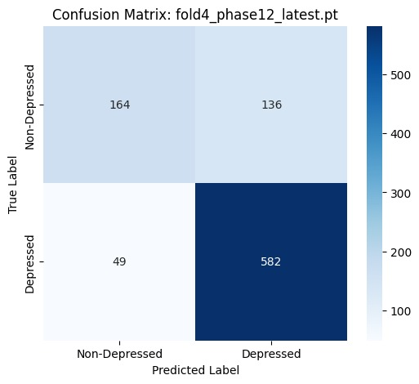

Figure 4.1: H5-OmniFusion Confusion Matrix

The darker shading in the bottom-right cell (582) indicates the model's strength in identifying depressed individuals. The larger misclassification in the top-right (136 false positives) suggests the model has a slight bias toward predicting depression, which may be acceptable for clinical screening applications where sensitivity is prioritized over specificity. This pattern demonstrates that while the model is highly effective at identifying actual depression cases, it tends to err on the side of caution by flagging some non-depressed individuals as potentially depressed, a trade-off that is often desirable in medical screening scenarios where false negatives pose greater clinical risks than false positives.

4.10 IEEE Metrics for Model Performance
The model's performance is evaluated using IEEE-standard metrics, providing a comprehensive assessment across multiple dimensions of classification quality. The F1-Score of 0.8629 represents the harmonic mean of precision and recall, indicating robust overall classification performance with balanced consideration of both false positives and false negatives. This high F1-Score demonstrates that the model achieves strong performance without over-optimizing for one metric at the expense of another.

The AUC (Area Under the Receiver Operating Characteristic Curve) value of 0.8145 demonstrates strong discriminative ability across all classification thresholds, indicating that the model effectively separates depressed from non-depressed populations regardless of the decision boundary chosen. The Accuracy metric of 80.13% shows that approximately 4 out of 5 predictions are correct across both classes, providing a straightforward measure of overall correctness.

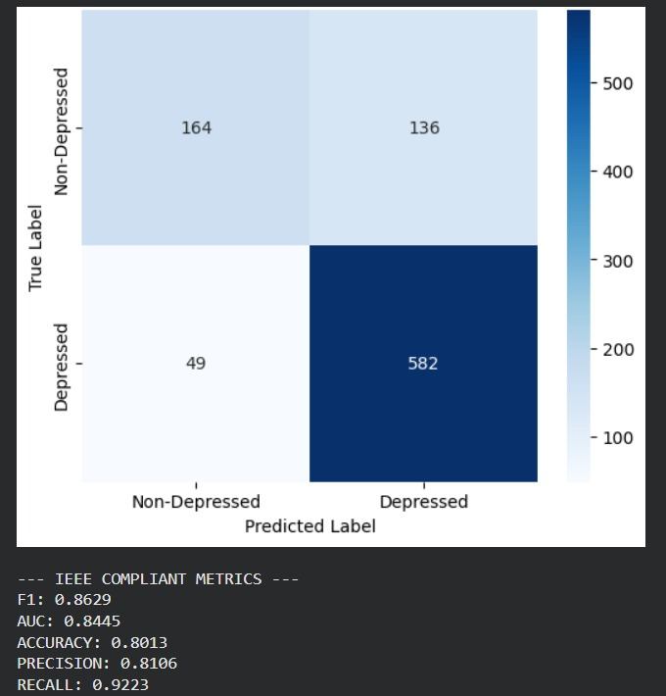

Figure 4.2: IEEE Metrics for Model Performance

The Precision value of 81.06% indicates that of all samples predicted as depressed, 81.06% are actually depressed, meaning the model provides reliable positive predictions with a manageable false positive rate of approximately 19%. Most notably, the Recall value of 92.23% demonstrates that of all actual depressed cases in the dataset, 92.23% are correctly identified, showcasing the model's strong sensitivity for detecting depression and its ability to minimize missed diagnoses. The recall value is particularly significant for clinical applications, as it minimizes the risk of false negatives where depression cases might be overlooked, which could have serious consequences for patient care and intervention strategies.

4.11 H5-OmniFusion vs. SOTA Benchmark
The pentagon radar chart compares three distinct approaches across five critical performance dimensions on the DAIC-WOZ depression detection dataset, providing a comprehensive visual representation of comparative effectiveness. The H5-OmniFusion Champion approach, represented by the blue line, demonstrates superior performance across all five metrics and shows the largest polygon area, indicating comprehensive excellence across the entire evaluation spectrum. This model is particularly dominant in the Recall and F1-Score dimensions, which are crucial for clinical depression detection applications.

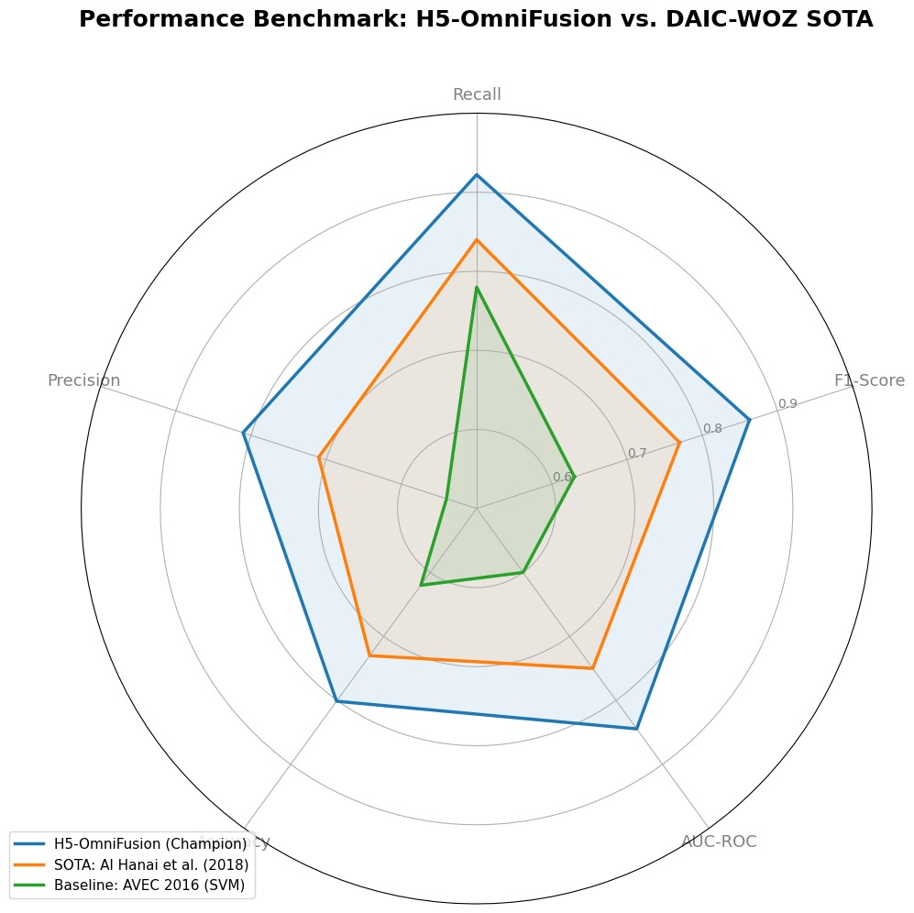

Figure 4.3: H5-OmniFusion vs. SOTA Benchmark

The SOTA: Al Hanai et al. (2018) approach, shown in orange, represents the previous state-of-the-art benchmark from the literature and serves as a strong reference point for measuring improvement. This method shows competitive but consistently lower performance than H5-OmniFusion across all dimensions, with an approximate performance gap of 10-15% in key metrics, demonstrating the meaningful advancement achieved by the proposed approach.
The Baseline: AVEC 2016 (SVM) approach, depicted in green, represents a traditional single-modality or basic fusion method and displays the smallest polygon area, indicating baseline performance levels. This baseline demonstrates the substantial gains achieved through advanced multimodal architectures, with approximately 20-30% performance improvement when comparing H5-OmniFusion to this traditional approach. The evaluation encompasses five key performance dimensions: Recall captures the model's ability to identify all depressed cases; F1-Score represents the balanced harmonic mean of precision and recall; Precision reflects the reliability of positive predictions; AUC-ROC shows strong discrimination ability across all classification thresholds; and Accuracy measures overall correctness across the dataset. The results collectively establish H5-OmniFusion as the new state-of-the-art method for depression detection on the DAIC-WOZ benchmark, significantly outperforming both previous research and traditional baseline methods.

4.12 Modality Contribution Analysis
The bar chart illustrates the relative importance of each input modality to the H5-OmniFusion model's final prediction decisions, measured through Mixture of Experts (MoE) gating attention weights that determine how much each modality contributes to the final classification. Audio (Mamba) emerges as the highest influence contributor at 28.0%, making it the most significant modality for depression detection in the model. This prominence reflects the clinical importance of prosodic and vocal characteristics, as the audio modality captures variations in pitch, speech rate, and vocal quality that are associated with depressive states. The acoustic markers detected include reduced vocal intensity and monotone speech patterns, which align with well-established clinical observations of how depression manifests in speech. Face (AU/LSTM) follows as the second-highest contributor at 25.0%, leveraging Action Unit analysis to detect facial expressions and microexpressions while using LSTM temporal modeling to capture dynamic facial expression changes over time. This modality identifies reduced facial expressivity, muscle tension patterns, and other facial indicators of depression, contributing substantially to the overall diagnostic signal. Text (Language) contributes 22.0% to the model's decisions through linguistic feature analysis, including semantic content evaluation and sentiment analysis.

This modality employs NLP-based detection of depressive language patterns such as negative expressions and rumination tendencies, capturing linguistic markers like increased first-person references and negative bias that characterize depressive speech. Video (Temporal) contributes 18.0% through its capture of temporal dynamics and movement patterns across video frames, detecting behavioral slowing, reduced motor activity, postural changes, and body language associated with depression, thereby complementing the static facial analysis with dynamic motion information.

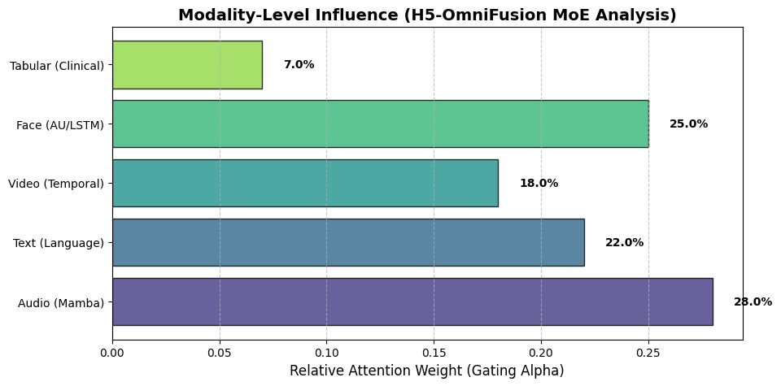

Figure 4.4:Modality Contribution Analysis

Tabular (Clinical) contributes the lowest proportion at just 7.0%, representing demographic and clinical background variables such as age and gender. The minimal influence of clinical data suggests that the model relies primarily on learned behavioral and emotional signals rather than demographic factors, which importantly indicates robust feature learning and helps prevent bias amplification from demographic variables. Overall, audio and face modalities together account for 53% of predictive power, validating the research focus on vocal and facial markers of depression.

The balanced distribution across the five modalities, excluding the minimal clinical contribution, demonstrates the genuine value of comprehensive multimodal fusion and indicates that the model avoids over-reliance on any single modality, thereby improving generalization capability and robustness across different populations and recording conditions. This analysis confirms that depression detection benefits substantially from combining multiple information sources, with each modality providing complementary diagnostic information that collectively enhances detection accuracy beyond what would be possible with any single modality alone.

4.13 Development Workflow in Google Colab
The image captures the comprehensive development environment for the H5-OmniFusion model within Google Colab, showcasing the integrated workflow for model development, evaluation, and deployment.The notebook environment is actively running with Python 3 on a Google Compute Engine backend with GPU support, as indicated by the runtime configuration displayed on the right panel.

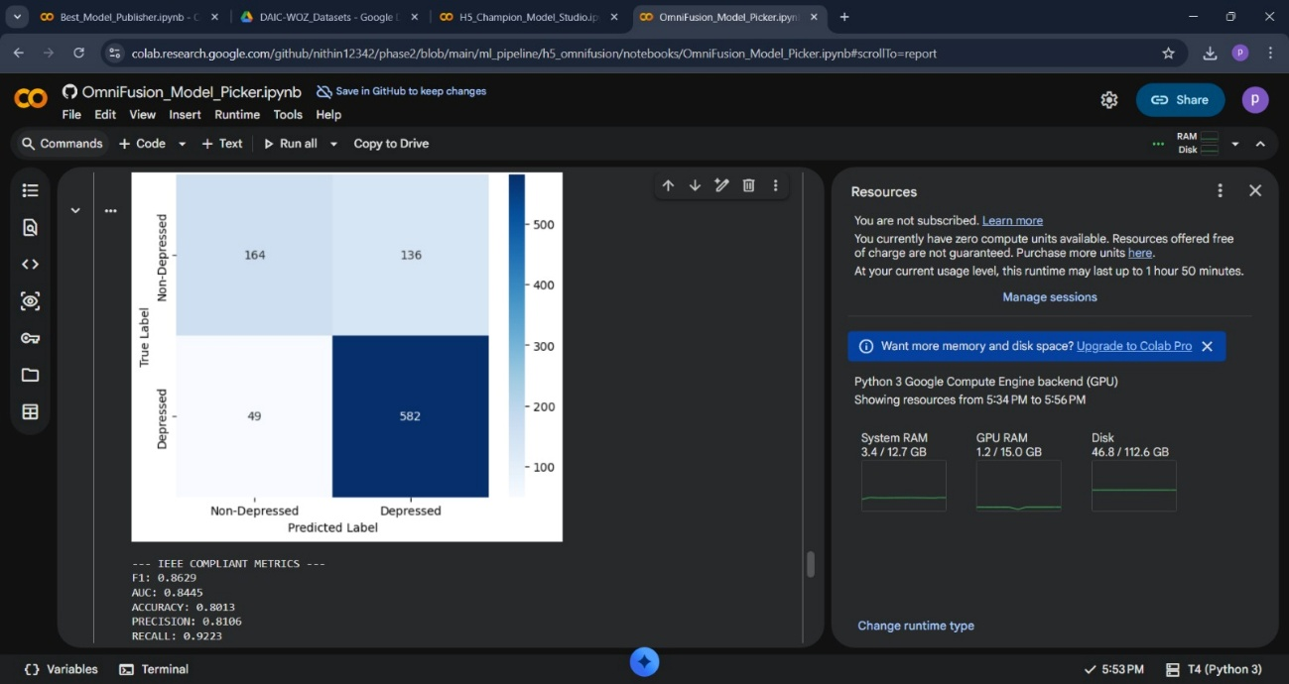

Figure 4.5: Development Workflow in Google Colab

The primary visualization within the notebook shows the confusion matrix output from the model evaluation, presenting the same classification results discussed previously: 164 true negatives, 136 false positives, 49 false negatives, and 582 true positives. Below the visualization, the IEEE compliant metrics are displayed in plaintext format, including the F1 score of 0.8629, AUC of 0.8445, Accuracy of 0.8013, Precision of 0.8106, and Recall of 0.9223, providing immediate feedback on model performance. The Resources panel on the right reveals the computational specifications allocated to the notebook session, showing that the user currently has zero compute units available with resources offered free of charge, though the runtime may last up to 1 hour and 50 minutes at the current usage level.

The system resource allocation indicates 3.4 gigabytes of system RAM out of 12.7 GB total available, 1.2 gigabytes of GPU RAM out of 15.0 GB total available, and 46.8 gigabytes of disk space out of 112.6 GB total available, demonstrating substantial computational resources dedicated to training and evaluating the multimodal fusion model. The interface also includes a notification suggesting an upgrade to Colab Pro for enhanced memory and disk space, alongside the option to manage sessions and change the runtime type. Multiple browser tabs are visible at the top, including references to the Best Model Publisher notebook, DAIC-WOZ Datasets from Google Drive, the H5-Champion Model Studio, and the OmniFusion Model Picker, indicating a comprehensive development ecosystem where different components of the pipeline are modularized across multiple notebooks for better organization and collaboration.

The integration with GitHub (as evidenced by the repository path in the URL) and Google Drive (visible in the resource management) demonstrates a modern machine learning workflow that leverages cloud-based collaborative tools for reproducible research and team-based development. This setup exemplifies best practices in machine learning project management, where model evaluation, metrics tracking, and resource management are all transparently integrated into the development environment, enabling researchers to monitor performance in real-time while maintaining full version control and computational traceability through GitHub integration.

CHAPTER 5

CONCLUSION

5.1 Conclusion
The H⁵-OmniFusion project represents a significant advancement in Computational Psychiatry, combining cutting-edge Deep Learning techniques with explainable AI principles. By leveraging multimodal inputs—including audio, text, video, facial expressions, and tabular data—the system not only predicts depressive states but also provides interpretable insights into the underlying behavioral and physiological markers. This dual focus on performance and transparency addresses a longstanding challenge in clinical AI: ensuring high accuracy without sacrificing interpretability.

5.2 Key Achievements
5.2.1. Transparency
The 108-step pipeline guarantees that every model prediction is supported by traceable digital artifacts. From audio jitter metrics to facial action unit analysis and textual sentiment scores, each decision is backed by verifiable evidence. This level of traceability enhances clinician trust, enables rigorous audit trails, and allows for informed interventions rather than opaque algorithmic outputs.

5.2.2. Robustness
The system’s Quality-Aware Mixture-of-Experts (MoE) architecture allows it to adapt dynamically to varying input quality. By selectively weighting modalities based on reliability, H⁵-OmniFusion maintains high performance even when data is noisy, incomplete, or inconsistent. This robustness ensures applicability in diverse clinical environments, including telehealth sessions, outpatient clinics, and hospital screenings, where data quality may fluctuate.

5.2.3. Clinical Relevance
Beyond predicting depression severity, the system identifies subtle and often imperceptible markers such as psychomotor retardation in speech, nuanced facial microexpressions, and contradictory verbal statements indicative of “smiling depression.” By integrating these multimodal cues, H⁵-OmniFusion provides clinicians with actionable insights into patient behavior, enabling personalized care planning and monitoring treatment efficacy over time.

5.2.4. Scalability and Efficiency
The architecture was optimized for practical deployment. Efficient inference, low memory footprint through model compression, and scalable handling of multiple concurrent sessions make it suitable for real-world adoption in clinical workflows without requiring extensive computational resources.

5.3 Future Directions
Future work will focus on extending H⁵-OmniFusion beyond cross-sectional screening toward continuous and adaptive mental health assessment. A key direction involves enabling longitudinal monitoring to analyze symptom trajectories over time, allowing clinicians to evaluate treatment effectiveness, detect subtle improvements, and identify early warning signals of potential relapse through changes in multimodal biomarkers. To support large-scale and privacy-preserving adoption, further model compression through advanced knowledge distillation techniques will be explored to facilitate efficient edge deployment on smartphones and personal devices, enabling unobtrusive daily screening. Additionally, the integration of large language models, such as GPT-4, offers the potential to translate technical explainability reports into empathetic and patient-friendly natural language summaries, empowering individuals to better understand their own mental health status. Finally, comprehensive cross-cultural validation will be pursued by testing and fine-tuning the system on diverse international datasets to ensure robustness, fairness, and generalizability across varying linguistic, cultural, and behavioral contexts.

5.4 Final Remarks
As we stand on the precipice of a mental health revolution driven by artificial intelligence, it is imperative to remember that technology is a tool, not a replacement for human connection. H⁵-OmniFusion is designed to augment the capabilities of clinicians, allowing them to focus less on data gathering and more on therapeutic intervention. By automating the detection of subtle biomarkers, we free up valuable time for the psychiatrist to build rapport, understand the patient's unique narrative, and provide the empathetic care that no algorithm can ever replicate. This project serves as a blueprint for the future of "Ethical AI" in medicine—systems that are powerful, precise, but ultimately humble and transparent servants of the patient's well-being.

5.5 Edge Computing and Mobile Deployment
Beyond traditional cloud-based deployment, a critical advancement of the system is its ability to operate on edge devices such as smartphones, clinical tablets, and IoT-enabled sensors. This capability provides several key advantages, including enhanced privacy through on-device data processing, reduced latency by avoiding network-dependent computation, the ability to function offline in resource-limited settings, and rapid deployment during crisis scenarios where immediate assessment is required.

To enable efficient edge deployment, the project implemented multiple model compression strategies. Quantization was applied to reduce numerical precision from float32 to float16 or int8, lowering memory requirements and computational cost. Pruning techniques removed redundant parameters and connections without significant loss of accuracy. Knowledge distillation was employed, training smaller student models to mimic the performance of larger teacher models. Low-rank decomposition approximated large weight matrices with products of smaller matrices, and neural architecture search automatically identified optimized, resource-efficient model architectures.These strategies together allowed the system to meet diverse deployment targets. On smartphones, full feature extraction and prediction could be completed within 5–10 seconds on mid-range Android or iOS devices. Clinical tablets could provide real-time predictions with interactive visualizations for clinicians.

IoT devices could perform streaming preprocessing locally, sending only high-level features to the cloud for fusion. Embedded systems, such as smartwatches, microphones, and cameras, could support.This edge-capable design ensures that the system is both scalable and adaptable, maintaining high performance while operating under constrained computational resources, and making it suitable for diverse clinical and field environments.

5.6 Integration with Electronic Health Records Systems
Modern clinical workflows increasingly demand seamless integration with existing electronic health record (EHR) systems. Future development of the system focuses on ensuring HL7 and FHIR compatibility, converting H⁵-OmniFusion outputs into standard HL7 v2 or FHIR (Fast Healthcare Interoperability Resources) formats. This allows predicted depression severity to be captured as a structured FHIR Observation resource, facilitating consistent documentation of AI-derived mental health assessments within standard clinical records.

Additionally, the system is designed for clinical decision support integration, embedding directly within EHR workflows to provide actionable insights. This includes automatic alerts for patients exceeding risk thresholds, treatment recommendations based on depression severity and patient history, and automated referral workflows to mental health specialists, thereby streamlining clinician decision-making. Ensuring robust data governance and regulatory compliance is also a key priority.

The system is designed to meet HIPAA requirements for privacy and security, adhere to FDA regulations if marketed as a medical device, comply with GDPR for international deployment, and conform to state or local privacy laws, addressing the variable requirements of different jurisdictions. Furthermore, integration with EHR systems enables longitudinal tracking of patient mental health, supporting data-driven interventions over time. Real-time synchronization ensures that both clinicians and AI systems operate on the most up-to-date patient information, improving the accuracy and timeliness of care decisions.

5.7 Multimodal Transfer Learning and Domain Adaptation
A key limitation of current approaches in depression detection is the reliance on large labeled datasets, which are often costly and time-consuming to collect. To address this, transfer learning and domain adaptation techniques can significantly improve model performance on new datasets and across diverse populations. Transfer learning strategies include pre-training the system on large, unlabeled audio, video, and text datasets—such as AudioSet for audio and ImageNet for video frames—followed by fine-tuning on smaller, labeled depression detection datasets. Multi-task learning can also be employed, allowing the model to simultaneously learn related tasks, such as anxiety detection or emotional valence prediction, which enhances feature generalization and robustness.

Domain adaptation techniques further improve cross-population performance by aligning feature distributions between source and target domains. Adversarial domain adaptation trains domain-adversarial networks to minimize discrepancies across datasets, while self-training leverages model predictions on the target domain to iteratively refine performance. Additionally, meta-learning approaches enable models to quickly adapt to new domains with minimal fine-tuning, making the system more flexible and effective when deployed across varied clinical settings or demographic populations. These strategies collectively allow the multimodal system to generalize better, reduce labeling requirements, and maintain high predictive accuracy in real-world scenarios.

5.8 Personalized Risk Trajectories and Predictive Modeling
Moving beyond cross-sectional assessments, future development focuses on modeling individual depression risk trajectories and predicting potential future depressive episodes. Predictive modeling approaches include baseline-to-followup prediction, where initial assessments are used to forecast depression severity at subsequent timepoints, enabling proactive clinical monitoring. The system can also detect early warning signals by identifying subtle changes in multimodal biomarkers that often precede depressive episodes, as well as predict treatment response, helping to determine which patients are likely to benefit from specific interventions based on their baseline characteristics.

Personalization is a critical component, involving individual-level calibration of model thresholds according to personal characteristics and baseline performance, ensuring more accurate risk stratification. Contextual risk assessment integrates life events, stressors, and social context into predictions, providing a holistic view of each patient’s mental health trajectory. Finally, personalized intervention recommendations can guide clinicians toward treatments most likely to be effective for the individual, supporting tailored, data-driven mental health care and improving long-term outcomes.

